Internship Project Report
Project Title: Gemini Historical Artifact Description
Submitted in partial fulfilment of the requirements for the
Google Cloud Generative AI
conducted by

SmartBridge

Submitted by

Team Leader: Surendra Venkata Kondalarao Pechetti

Team member: Maddala Divya Savitri

Team member: Madireddy Manoj Satya Prasad

Team member: Moka Naresh

Team ID: LTVIP2026TMIDS89050
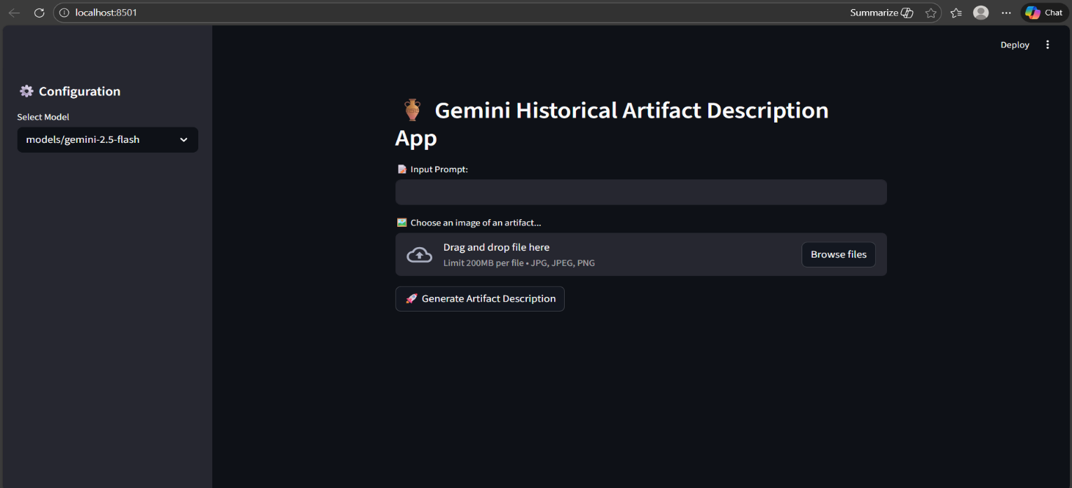

- INTRODUCTION

1.1 Project Overview
Gemini Historical Artifact Description is a cloud-based web application that uses Generative AI to automatically generate detailed descriptions of historical artifacts from images and user input.
The system leverages Google’s Gemini model to analyze uploaded artifact images and produce intelligent, context-aware descriptions.

1.2 Purpose
- The purpose of the Gemini Historical Artifact Description project is to build an AI-powered system that automatically generates meaningful and educational descriptions of historical artifacts from images.

Main Purposes
- Automate Artifact Documentation
Reduce manual effort in writing descriptions for historical objects.
- Enhance Learning
Help students understand artifacts with clear historical context, origin, and cultural importance.
- Support Museums & Researchers
Assist in cataloging and documenting artifacts quickly and efficiently.
- Demonstrate AI Application
Showcase how Generative AI and NLP can be applied in real-world cloud-based applications.
- Improve Accessibility to History
Make historical knowledge more accessible to everyone through AI-generated explanations.
2. IDEATION PHASE
2.1 Problem Statement
Many historical artifacts stored in museums, educational institutions, and private collections lack detailed, accessible, and easily understandable documentation. Preparing accurate descriptions requires expert knowledge in history and archaeology, which is time-consuming and not always available.
2.2 Empathy Map Canvas
The Empathy Map helps us understand the target users of the system and design the application according to their needs.
🎯 Target Users:
- Students
- History researchers
- Museum curators
- Educators
2.3 Brainstorming
Basic Features
- Image upload functionality
- AI-generated artifact name
- Time period estimation
- Cultural significance explanation

3. REQUIREMENT ANALYSIS
3.1 Customer Journey Map
User Action:
- Sees the application online or hears about it from teachers/museums.
User Thoughts:
- “This might help me understand artifacts easily.”
User Feelings:
- Curious and interested
Pain Point:
- Not sure about AI accuracy
3.2 Solution Requirement
Functional Requirements:
User Requirements
- User should be able to upload an artifact image.
- User should be able to enter optional context/topic.
- System should generate a historical description.
Non-Functional Requirements:
- Fast response time
- User-friendly interface
- Secure API integration
3.3 Data Flow Diagram (DFD)
Input → Processing → Output
User Inputs → Gemini AI Processing → Generated Itinerary
3.4 Technology Stack
Programming Language – Python
Python is used as the core programming language for developing the system. It is chosen because of its simplicity, readability, and strong support for artificial intelligence, data processing, and API integration.
Web Framework – Streamlit
Streamlit is used to build the user interface of the application. It allows developers to quickly create interactive web applications using simple Python code without requiring knowledge of HTML, CSS, or JavaScript.
AI Model – Google Gemini 1.5 Flash
Google Gemini 1.5 Flash is used as the core artificial intelligence model in the system. It provides fast and accurate responses for tasks such as text understanding, content generation, and analysis, making it suitable for real-time AI applications.
API Integration – Google Generative AI API
The Google Generative AI API is used to connect the application with the Gemini AI model. It enables seamless communication between the system and the AI service
Environment Management – python-dotenv
python-dotenv is used to manage environment variables securely. It helps store sensitive data such as API keys and configuration settings in a separate file,
4. PROJECT DESIGN
4.1 Problem Solution Fit
he solution strongly aligns with the identified problem because it directly automates the artifact documentation process using advanced Generative AI, making historical knowledge faster, easier, and more accessible.
4.2 Proposed Solution
Develop an AI-powered web application that:
- Accepts artifact images as input
- Uses Gemini developed by Google
- Generates detailed, context-aware historical descriptions
- Provides origin, time period, and cultural significance
- Delivers results instantly through a user-friendly interface
4.3 Solution Architecture
User Interface (Streamlit) → API Integration → Gemini AI Model → Generated Itinerary Output
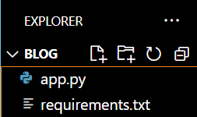

5. PROJECT PLANNING & SCHEDULING

5.1 Project Planning
Ideation – 1 Week
In this phase, the project idea was planned and defined. Requirements were gathered, objectives were set, and the overall system design and workflow were outlined.

Development – 2 Weeks
During this phase, the actual implementation of the system was carried out. The application was developed using Python, Streamlit, and AI integration, and core functionalities were built.

Testing – 1 Week
In the testing phase, the system was checked for errors, bugs, and performance issues. Different test cases were executed to ensure the application works correctly and reliably.

Documentation – 1 Week
This phase involved preparing project documentation, including reports, technical details, user guides, and explanations of the system’s features and workflow.

6. FUNCTIONAL AND PERFORMANCE TESTING
6.1 Performance Testing
- System responds within seconds
- Handles multiple inputs efficiently
- Accurate AI-generated itineraries
App.py Code:
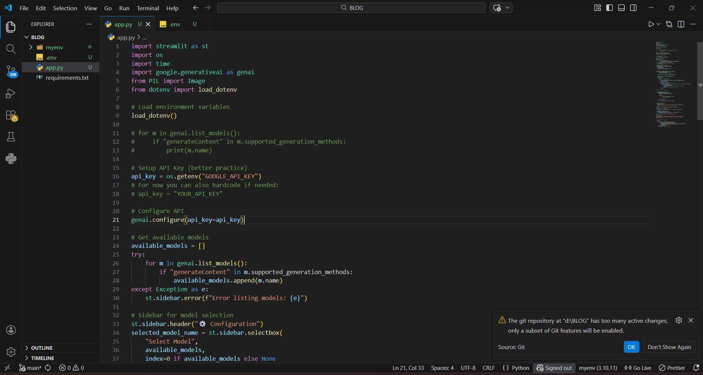
Requirements.txt:
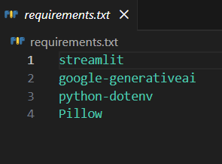
Running the Application:
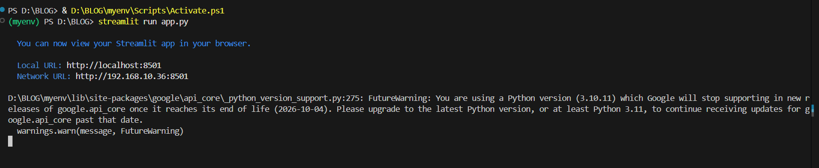
User Interface:
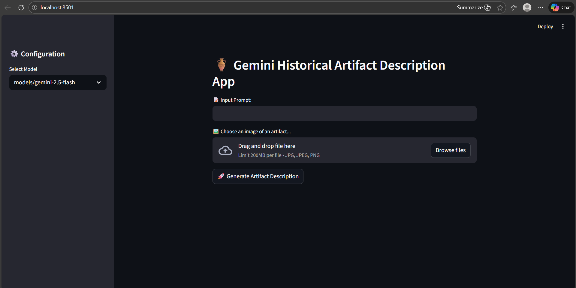

7. RESULTS
7.1 Output Screenshots
Include screenshots of:
User input form:
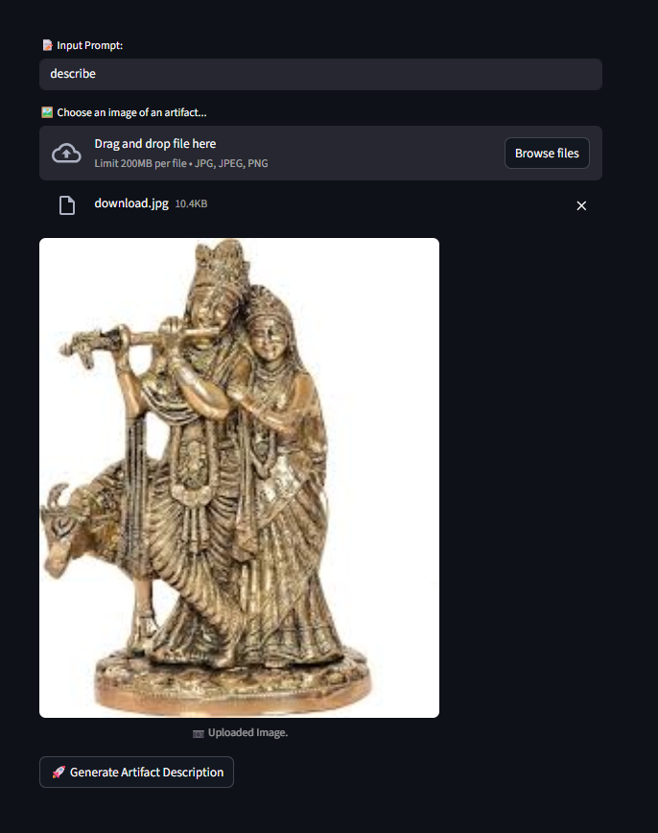
Generated itinerary:
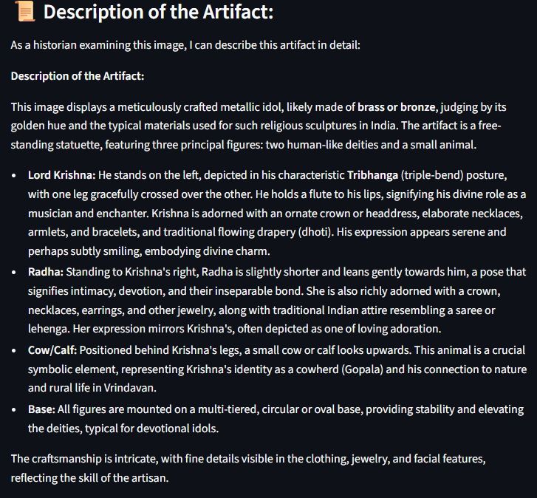

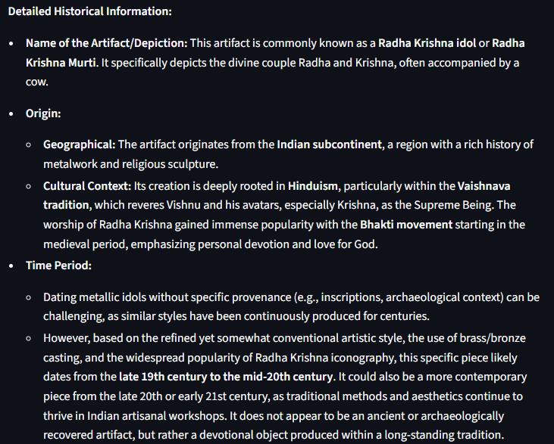
8. ADVANTAGES & DISADVANTAGES
Advantages
1️⃣ Saves Time
2️⃣ Easy to Use
3️⃣ Improves Learning
4️⃣ Accessible Knowledge.
5️⃣ Cloud-Based & Scalable
6️⃣ Encourages Digital Transformation

Disadvantages
1️⃣ Accuracy Limitations
2️⃣ Dependency on Internet & API
3️⃣ Limited Recognition

9. CONCLUSION

The Gemini Historical Artifact Description project successfully demonstrates how Generative AI can be applied to solve real-world problems in education and cultural heritage documentation. By integrating Gemini developed by Google, the system analyzes artifact images and generates meaningful, structured, and context-aware historical descriptions.
This project reduces manual research effort, improves accessibility to historical knowledge, and supports digital transformation in museums and educational institutions. It provides students and researchers with a quick, intelligent, and user-friendly way to understand artifacts without requiring deep domain expertise.
Although AI-generated content may require verification for accuracy, the system serves as a powerful supportive tool for learning and documentation. Overall, the project highlights the practical implementation of cloud-based AI solutions and demonstrates the potential of multimodal Generative AI in preserving and promoting cultural heritage.
However, it is important to acknowledge that AI-generated outputs may not always be perfectly accurate and should be verified for critical academic or professional use. Despite this limitation, the application serves as a powerful assistive tool that enhances efficiency, improves learning experiences, and encourages innovation in cultural documentation.

10. FUTURE SCOPE
1️⃣ Improved Accuracy & Validation
2️⃣ Multi-Language Support
3️⃣ Mobile Application Development
4️⃣ Advanced AI Capabilities

11. APPENDIX
Github Link: https://github.com/Naresh1665/BLOG

Demo Video Link:
https://drive.google.com/file/d/1YZi8HOdK9zx7_6w5JDG2KplO_w4JvsrI/view?usp=drive_link

